SAVEETHA INSTITUTE OF MEDICAL AND TECHNICAL
SCIENCES
COMPUTER SCIENCE AND ENGINEERING
OCTOBER – 2026
ASSIGNMENT – 2
INTERNET PROGRAMMING
Course Code | CSA43
Course Name | INTERNET PROGRAMMING
Submitted by | BAVANI SRI M (19231405)
Academic Year | 2026–2027

TABLE OF CONTENTS
Section | Description | Page range
Question 1 | JavaScript DOM and Regular Expression Validation | 3–6
Question 2 | Dynamic E-commerce Product Search using DOM and AJAX | 7–10
Question 3 | XMLHttpRequest, Ready States and AJAX Working | 11–13
Question 4 | TypeScript Class and Object for Student Management | 14–16
Question 5 | Online Banking Form Validation using JavaScript and Regular Expressions | 17–19
References | Learning resources and technical documentation | 20

Note: The page ranges are indicative and may shift slightly if the document is edited or opened with different printer settings.

Q1 • JavaScript DOM Manipulation and Regular Expression Validation

1. Introduction
Online registration forms are commonly used by educational institutions to collect student details. A registration form should accept valid information and immediately inform users when an entry is incorrect. JavaScript can perform client-side validation without reloading the webpage. The Document Object Model (DOM) allows JavaScript to access and modify HTML elements, while Regular Expressions (RegEx) provide patterns for checking text such as names, email addresses, mobile numbers and passwords.
For this question, consider a student registration webpage that collects the student's name, email ID, mobile number and password. When the user submits the form, JavaScript reads the entered values, checks each value against validation rules and displays suitable error messages near the relevant fields. If all values are valid, a success message is displayed. The example demonstrates front-end validation; a real application must repeat important checks on the server.

2. Role of DOM manipulation
The DOM represents an HTML page as a tree of objects. JavaScript can select an element using methods such as getElementById(), querySelector() and querySelectorAll(). The value property reads form input, textContent changes displayed text, and classList can add or remove CSS classes. The addEventListener() method attaches an event handler, such as submit, click or input, to an element.
- getElementById() selects a form control or message element by its unique ID.
- addEventListener('submit', ...) runs validation when the form is submitted.
- preventDefault() stops the browser's normal form submission and page reload.
- textContent displays an error or success message safely as text.
- classList.add() and classList.remove() can apply visual error and success styles.

3. Regular Expressions used for validation
A regular expression is a sequence of characters that defines a search or validation pattern. In JavaScript, a RegExp can be created between slash characters or with the RegExp constructor. The test() method returns true when the input matches the pattern.
Field | Sample pattern | Purpose
Student name | ^[A-Za-z][A-Za-z .'-]{1,49}$ | Starts with a letter; permits letters, spaces, dots, apostrophes and hyphens.
Email ID | ^[^\s@]+@[^\s@]+\.[^\s@]{2,}$ | Checks for a local part, @ symbol, domain and suffix.
Mobile number | ^[6-9]\d{9}$ | Accepts a 10-digit Indian mobile number beginning with 6, 7, 8 or 9.
Password | ^(?=.*[a-z])(?=.*[A-Z])(?=.*\d)(?=.*[@$!%*?&])[A-Za-z\d@$!%*?&]{8,}$ | Requires at least 8 characters, uppercase, lowercase, digit and special character.

These patterns are practical front-end checks, not complete definitions of every possible valid name, email address or telephone number. The rules should be adjusted to the institution's requirements.

4. HTML and JavaScript implementation
The following program contains the registration form and validation logic in one HTML file. Each input has a label, and a separate message area is provided for validation feedback.
<!DOCTYPE html>
<html lang="en">
<head>
<meta charset="UTF-8">
<meta name="viewport" content="width=device-width, initial-scale=1.0">
<title>Student Registration</title>
<style>
body { font-family: Arial, sans-serif; margin: 30px; }
form { max-width: 420px; padding: 20px; border: 1px solid #ccc; }
label { display: block; margin-top: 12px; }
input { width: 100%; padding: 8px; box-sizing: border-box; }
.error { color: #c00000; font-size: 13px; }
.success { color: green; font-weight: bold; }
</style>
</head>
<body>
<h2>Student Online Registration</h2>
<form id="registrationForm" novalidate>
<label for="studentName">Student Name</label>
<input id="studentName" type="text">
<small id="nameError" class="error"></small>

<label for="email">Email ID</label>
<input id="email" type="email">
<small id="emailError" class="error"></small>

<label for="mobile">Mobile Number</label>
<input id="mobile" type="tel">
<small id="mobileError" class="error"></small>

<label for="password">Password</label>
<input id="password" type="password">
<small id="passwordError" class="error"></small>

<button type="submit">Register</button>
<p id="result"></p>
</form>

<script>
const form = document.getElementById("registrationForm");

form.addEventListener("submit", function(event) {
event.preventDefault();

const name = document.getElementById("studentName").value.trim();
const email = document.getElementById("email").value.trim();
const mobile = document.getElementById("mobile").value.trim();
const password = document.getElementById("password").value;

const namePattern = /^[A-Za-z][A-Za-z .'-]{1,49}$/;
const emailPattern = /^[^\s@]+@[^\s@]+\.[^\s@]{2,}$/;
const mobilePattern = /^[6-9]\d{9}$/;
const passwordPattern =
/^(?=.*[a-z])(?=.*[A-Z])(?=.*\d)(?=.*[@$!%*?&])[A-Za-z\d@$!%*?&]{8,}$/;

let valid = true;
document.querySelectorAll(".error").forEach(e => e.textContent = "");
document.getElementById("result").textContent = "";

if (!namePattern.test(name)) {
document.getElementById("nameError").textContent =
"Enter a valid name (2–50 characters).";
valid = false;
}
if (!emailPattern.test(email)) {
document.getElementById("emailError").textContent =
"Enter a valid email address.";
valid = false;
}
if (!mobilePattern.test(mobile)) {
document.getElementById("mobileError").textContent =
"Enter a valid 10-digit Indian mobile number.";
valid = false;
}
if (!passwordPattern.test(password)) {
document.getElementById("passwordError").textContent =
"Use 8+ characters with uppercase, lowercase, number and symbol.";
valid = false;
}

if (valid) {
document.getElementById("result").textContent =
"Registration details are valid!";
document.getElementById("result").className = "success";
form.reset();
}
});
</script>
</body>
</html>

5. Working procedure and output
- The user enters the student name, email ID, mobile number and password.
- When Register is clicked, the submit event handler is executed.
- preventDefault() prevents the page from refreshing.
- The values are read from the input elements and checked using the four regular-expression patterns.
- If a value is invalid, a suitable message is placed in the corresponding small element. If all values are valid, a success message is displayed.
Sample valid input: Student Name – Bavani Sri; Email ID – bavani@example.com; Mobile Number – 9876543210; Password – Study@2026. Expected result: “Registration details are valid!” If the mobile number contains fewer than ten digits or the password does not contain the required character types, the corresponding error message appears without reloading the webpage.

6. Advantages and conclusion
- Immediate feedback helps users correct mistakes before submitting the form.
- DOM manipulation updates messages dynamically without rebuilding the entire page.
- Regular expressions provide a compact way to check common input formats.
- Client-side validation improves usability, but server-side validation is still necessary for security.
In conclusion, JavaScript DOM manipulation and Regular Expressions can be combined to validate student registration details efficiently. The submit event, preventDefault(), DOM selection methods and RegExp test() method make it possible to display field-specific error messages without reloading the webpage.
Key point: Client-side validation improves the user experience, but the server must independently validate and safely process submitted data.

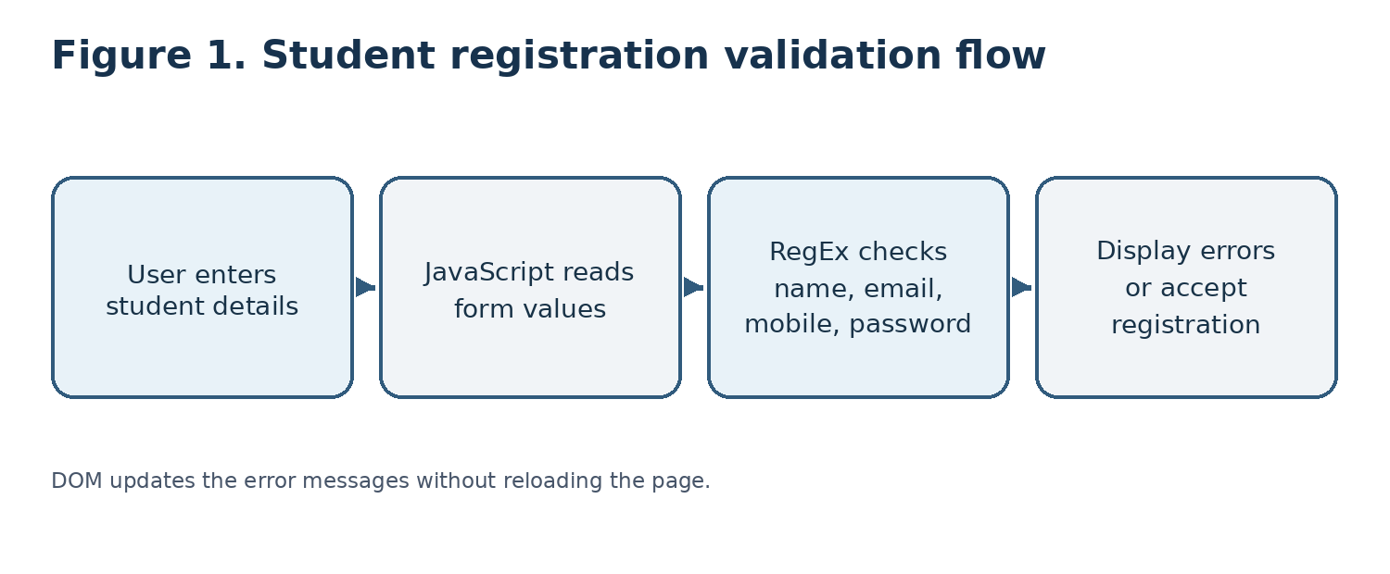
Figure 1: Student registration validation flow.

Q2 • Dynamic E-commerce Product Search using JavaScript DOM and AJAX

1. Introduction
An e-commerce website may contain hundreds or thousands of products. A search facility helps customers find products by entering a product name. A dynamic search webpage displays matching products while the user types, without requiring a complete page reload. JavaScript handles user events and updates the DOM, while AJAX requests product data from a server asynchronously.
AJAX stands for Asynchronous JavaScript and XML. Despite its name, modern AJAX applications commonly exchange JSON data rather than XML. In this example, the server returns a JSON array of product objects. JavaScript reads the response, filters or displays matching products and creates result elements dynamically.

2. Technologies and workflow
- HTML provides the search input and an area where product results will appear.
- CSS styles the search box and product cards.
- JavaScript listens for the input event and sends a request to the server.
- AJAX retrieves JSON data asynchronously using fetch() or XMLHttpRequest.
- DOM methods create product cards and insert them into the webpage.

3. JSON product data format
JSON (JavaScript Object Notation) is a lightweight text format used to exchange structured data. Each product can be represented by an object containing an ID, name, price, category and image path. A collection of products is represented as an array.
[
{
"id": 101,
"name": "Laptop",
"price": 55000,
"category": "Electronics",
"image": "images/laptop.jpg"
},
{
"id": 102,
"name": "Smartphone",
"price": 18000,
"category": "Electronics",
"image": "images/phone.jpg"
},
{
"id": 103,
"name": "Headphones",
"price": 2500,
"category": "Accessories",
"image": "images/headphones.jpg"
}
]

4. Program implementation using DOM and AJAX
The following example assumes that the server provides a GET endpoint at /api/products?q=searchText and responds with a JSON array. The endpoint is illustrative; it must be implemented on the server for the webpage to work with live data.
<!DOCTYPE html>
<html lang="en">
<head>
<meta charset="UTF-8">
<meta name="viewport" content="width=device-width, initial-scale=1.0">
<title>Dynamic Product Search</title>
<style>
body { font-family: Arial, sans-serif; margin: 30px; }
#searchBox { width: 100%; max-width: 450px; padding: 10px; }
#products { display: grid; grid-template-columns:
repeat(auto-fit, minmax(180px, 1fr)); gap: 15px; margin-top: 20px; }
.product { border: 1px solid #ccc; padding: 14px; border-radius: 8px; }
.product img { max-width: 100%; height: 110px; object-fit: contain; }
</style>
</head>
<body>
<h2>Search Products</h2>
<input id="searchBox" type="text"
placeholder="Enter a product name">
<p id="status" aria-live="polite"></p>
<div id="products"></div>

<script>
const searchBox = document.getElementById("searchBox");
const productsDiv = document.getElementById("products");
const statusText = document.getElementById("status");
let timer;

searchBox.addEventListener("input", function() {
clearTimeout(timer);
const query = searchBox.value.trim();

if (query === "") {
productsDiv.replaceChildren();
statusText.textContent = "Enter a product name to search.";
return;
}

// Small delay avoids sending a request for every keystroke.
timer = setTimeout(() => searchProducts(query), 300);
});

async function searchProducts(query) {
statusText.textContent = "Searching...";
productsDiv.replaceChildren();

try {
const response = await fetch(
"/api/products?q=" + encodeURIComponent(query)
);

if (!response.ok) {
throw new Error("Server returned " + response.status);
}

const products = await response.json();
displayProducts(products);
} catch (error) {
statusText.textContent = "Unable to load products. Please try again.";
console.error(error);
}
}

function displayProducts(products) {
productsDiv.replaceChildren();

if (!Array.isArray(products) || products.length === 0) {
statusText.textContent = "No matching products found.";
return;
}

statusText.textContent = products.length + " product(s) found.";

products.forEach(product => {
const card = document.createElement("article");
card.className = "product";

const name = document.createElement("h3");
name.textContent = product.name;

const price = document.createElement("p");
price.textContent = "Price: ₹" + product.price;

const category = document.createElement("p");
category.textContent = "Category: " + product.category;

card.append(name, price, category);
productsDiv.appendChild(card);
});
}
</script>
</body>
</html>

5. Explanation of the program
- The input event runs whenever the user types or deletes a character in the search box.
- A short 300 millisecond delay reduces unnecessary requests when the user types quickly. This is commonly called debouncing.
- fetch() sends an asynchronous HTTP GET request to the server. encodeURIComponent() safely encodes the search text for use in a URL.
- response.ok checks whether the HTTP response indicates success, and response.json() converts the JSON response into JavaScript objects.
- displayProducts() clears previous results, checks whether products were returned and creates an article element for each product.
- textContent is used for product text so that returned names are treated as text rather than executable HTML.

6. Expected output, benefits and conclusion
If the user enters “lap”, the browser sends a request such as /api/products?q=lap. If the server returns the Laptop object, the webpage displays a product card containing Laptop, its price and category. If no product matches, the message “No matching products found” is displayed. If the server is unavailable, an error message appears.
- Search results are updated without a full webpage refresh.
- Asynchronous requests allow users to continue interacting with the page while data is retrieved.
- JSON provides a simple structure for transferring product details.
- Debouncing reduces unnecessary network traffic.
- The server should validate the search query and return only the fields needed by the webpage.
In conclusion, JavaScript DOM manipulation and AJAX make e-commerce search faster and more interactive. The browser sends a request to the server, receives product details in JSON format and dynamically displays the matching products. A working implementation requires a server endpoint that returns valid JSON.
Key point: AJAX updates only the required part of the webpage; the example's /api/products endpoint must exist on the server.

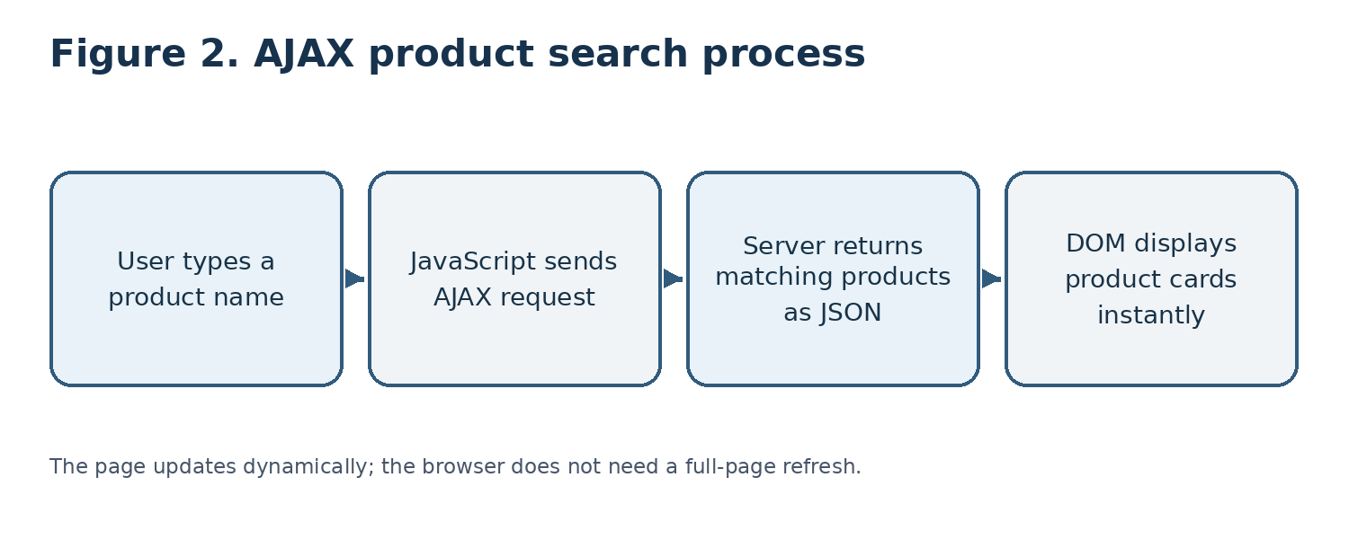
Figure 2: AJAX product search process.

Q3 • XMLHttpRequest Object, Ready States and AJAX Working

1. Introduction to AJAX
AJAX is a web development technique that allows a browser to exchange data with a server asynchronously and update part of a webpage without reloading the complete page. It improves responsiveness because the user can continue using the page while the request is being processed. AJAX can use different data formats, including JSON, XML and plain text.
The XMLHttpRequest (XHR) object is a browser API used to send HTTP requests and receive server responses from JavaScript. Although fetch() is a modern alternative, XMLHttpRequest remains important for understanding traditional AJAX programs and callback-based request handling.

2. Significance of XMLHttpRequest
- It sends HTTP requests such as GET and POST from JavaScript.
- It communicates with a server without requiring a complete page reload.
- It supports asynchronous request processing.
- It provides response information such as status code, response text and response headers.
- It can handle text, JSON and other supported response types.
- It provides event handlers and ready-state changes that allow JavaScript to respond when the request progresses.

3. XMLHttpRequest readyState properties
The readyState property indicates the current state of an XMLHttpRequest. It changes as the request is created, configured, sent and completed.
Value | Constant | Meaning
0 | UNSENT | The XMLHttpRequest object has been created, but open() has not been called.
1 | OPENED | open() has been called; request method and URL are set.
2 | HEADERS_RECEIVED | send() has been called and response headers have been received.
3 | LOADING | The response body is being received; responseText may contain partial data.
4 | DONE | The operation has completed. The response can now be checked.

4. Important methods and callback/event handlers
- new XMLHttpRequest() creates a request object.
- open(method, url, async) configures the HTTP method, destination URL and asynchronous mode.
- send() sends the request to the server. For a POST request, data may be passed as an argument.
- setRequestHeader() sets request headers, for example the Content-Type header.
- onreadystatechange is a callback property that runs whenever readyState changes.
- onload runs when the request completes successfully at the network level; the HTTP status must still be checked.
- onerror handles network-level errors, while ontimeout handles a request timeout.
- abort() cancels an active request.

5. AJAX program using XMLHttpRequest
The example below requests student information from a sample server endpoint. The server is expected to return JSON such as {"name":"Anu","department":"CSE"}. The URL is illustrative and should be replaced with a real endpoint.
<!DOCTYPE html>
<html lang="en">
<head>
<meta charset="UTF-8">
<meta name="viewport" content="width=device-width, initial-scale=1.0">
<title>AJAX Example</title>
</head>
<body>
<h2>Student Details</h2>
<button id="loadBtn">Load Student</button>
<p id="message" aria-live="polite"></p>
<div id="student"></div>

<script>
document.getElementById("loadBtn").addEventListener("click", function() {
const xhr = new XMLHttpRequest();
const message = document.getElementById("message");
const output = document.getElementById("student");

message.textContent = "Loading...";
output.replaceChildren();

// Configure an asynchronous GET request.
xhr.open("GET", "/api/student/1", true);
xhr.timeout = 10000;

xhr.onreadystatechange = function() {
if (xhr.readyState === XMLHttpRequest.DONE) {
if (xhr.status >= 200 && xhr.status < 300) {
try {
const data = JSON.parse(xhr.responseText);
const name = document.createElement("p");
const dept = document.createElement("p");

name.textContent = "Name: " + data.name;
dept.textContent = "Department: " + data.department;

output.append(name, dept);
message.textContent = "Student details loaded.";
} catch (error) {
message.textContent = "Invalid JSON received from server.";
}
} else {
message.textContent =
"Request failed. HTTP status: " + xhr.status;
}
}
};

xhr.onerror = function() {
message.textContent = "Network error. Check your connection.";
};

xhr.ontimeout = function() {
message.textContent = "The request timed out.";
};

xhr.send();
});
</script>
</body>
</html>

6. Working of the AJAX program
- The user clicks the Load Student button.
- JavaScript creates an XMLHttpRequest object and displays a loading message.
- open() configures an asynchronous GET request to /api/student/1.
- send() sends the request. The browser continues to display the webpage while the server processes it.
- onreadystatechange is called as readyState changes. When it becomes DONE (4), the program checks the HTTP status.
- If the status is in the 200–299 range, JSON.parse() converts the response text into a JavaScript object.
- The DOM is updated with the student's name and department. If the request fails, an appropriate message is shown.

7. Advantages and conclusion
AJAX reduces unnecessary full-page reloads, improves user interaction and allows data to be retrieved when needed. XMLHttpRequest provides control over HTTP methods, headers, response data and request events. Developers should check the HTTP status, handle invalid JSON, set suitable timeouts and avoid exposing sensitive information in client-side code.
In conclusion, XMLHttpRequest is a significant browser object for implementing asynchronous communication. Its readyState values describe the progress of a request, while callbacks such as onreadystatechange, onload, onerror and ontimeout allow the application to respond to completion and errors. The sample program demonstrates how AJAX retrieves JSON data and updates the DOM.
Key point: readyState 4 means the request operation has completed; always check the HTTP status before using the response.

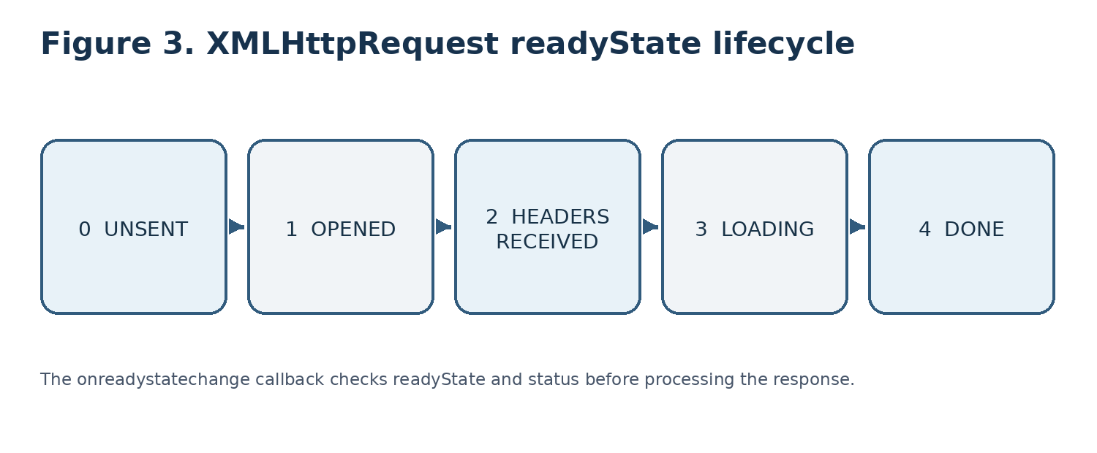
Figure 3: XMLHttpRequest readyState lifecycle.

Q4 • TypeScript Class and Object for Student Management System

1. Introduction to TypeScript
TypeScript is a programming language built on JavaScript that adds static type checking and other development features. TypeScript code is commonly compiled into JavaScript so that it can run in browsers or JavaScript environments. Types help developers identify certain mistakes during development and make large programs easier to maintain.
An engineering college Student Management System stores information such as student name, register number, department and marks. A class can define the structure and behaviour of a student, while objects represent individual students created from that class.

2. Class, object, properties and constructor
- Class: A blueprint that defines the data and methods shared by objects.
- Object: An instance created from a class. Each object stores its own property values.
- Properties: Variables declared inside a class to represent student details.
- Constructor: A special method named constructor() that runs when an object is created. It assigns initial values to properties.
- Method: A function defined inside a class that performs an operation, such as displaying student information.
TypeScript supports access modifiers such as public, private and protected. In the example, public properties are used so that the values can be accessed directly. A constructor parameter can also be declared with an access modifier to create and initialise a property, but the expanded form below is used to make the class structure clear.

3. TypeScript program
class Student {
name: string;
registerNumber: string;
department: string;
marks: number;

constructor(
name: string,
registerNumber: string,
department: string,
marks: number
) {
this.name = name;
this.registerNumber = registerNumber;
this.department = department;
this.marks = marks;
}

displayInformation(): void {
console.log("STUDENT INFORMATION");
console.log("Name: " + this.name);
console.log("Register Number: " + this.registerNumber);
console.log("Department: " + this.department);
console.log("Marks: " + this.marks);
}
}

// Creating objects
const student1 = new Student(
"Bavani Sri", "19231405", "CSE", 92
);

const student2 = new Student(
"Anu", "19231406", "ECE", 88
);

// Calling the method
student1.displayInformation();
student2.displayInformation();

4. Explanation of the program
- class Student declares a class named Student.
- name, registerNumber and department are declared with the string type. marks is declared with the number type.
- The constructor accepts four values when a Student object is created.
- The this keyword refers to the current object. For example, this.name = name stores the received name in that object's name property.
- displayInformation() is a method with return type void because it displays information and does not return a value.
- new Student(...) creates an object and calls the constructor automatically.
- student1 and student2 are two separate objects. Each object stores its own student details.
- Calling displayInformation() displays the properties belonging to the object on which the method is called.

5. Sample output
STUDENT INFORMATION
Name: Bavani Sri
Register Number: 19231405
Department: CSE
Marks: 92

STUDENT INFORMATION
Name: Anu
Register Number: 19231406
Department: ECE
Marks: 88

6. Compilation and execution
Save the program in a file named Student.ts. Install TypeScript in the development environment if it is not already available. The TypeScript compiler can be used to convert the file into JavaScript.
tsc Student.ts
node Student.js

The tsc command compiles the TypeScript source file and normally produces Student.js. The node command runs the generated JavaScript in a Node.js environment. In a browser-based project, the generated JavaScript file can instead be connected to an HTML page.

7. Benefits and conclusion
- Classes group related student data and operations in one place.
- Objects make it possible to represent many students using the same class definition.
- Type annotations help detect incorrect value types during compilation.
- Constructors initialise objects consistently.
- Methods provide reusable behaviour for displaying or processing student information.
In conclusion, TypeScript classes and objects provide an organised way to represent student details in a Student Management System. The Student class contains properties, a constructor and a displayInformation() method. Two objects demonstrate how the same class can store and display information for different students.
Key point: A class defines the structure; each object is an individual instance containing its own student information.

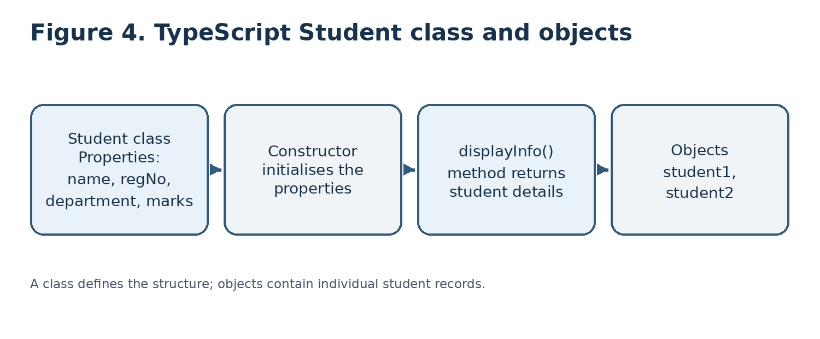
Figure 4: TypeScript Student class and objects.

Q5 • Online Banking Form Validation using JavaScript and Regular Expressions

1. Introduction
Online banking applications collect information through forms for activities such as account registration, profile updates and service requests. Incorrect account numbers, mobile numbers or email addresses can cause communication problems and processing errors. Form validation checks whether entered information follows the required format before the form is submitted.
JavaScript can validate fields in the browser and display messages immediately. Regular Expressions are used to test the format of the account number, mobile number and email ID. This assignment example demonstrates format validation only. A real banking system must use secure server-side validation, authentication, encryption and account verification; a pattern match cannot prove that an account exists or belongs to the user.

2. Validation requirements and patterns
Field | Validation rule | Example pattern
Account number | 12 digits in this sample system | ^\d{12}$
Mobile number | 10-digit Indian mobile number beginning from 6–9 | ^[6-9]\d{9}$
Email ID | Basic email format with @ and a domain suffix | ^[^\s@]+@[^\s@]+\.[^\s@]{2,}$

The 12-digit account number is an example rule chosen for this assignment. Actual account-number length and format vary between banks. The bank's official specification must be used in a real application.

3. HTML and JavaScript implementation
<!DOCTYPE html>
<html lang="en">
<head>
<meta charset="UTF-8">
<meta name="viewport" content="width=device-width, initial-scale=1.0">
<title>Banking Form Validation</title>
<style>
body { font-family: Arial, sans-serif; margin: 30px; }
form { max-width: 430px; padding: 20px; border: 1px solid #bbb; }
label { display: block; margin-top: 12px; }
input { width: 100%; padding: 9px; box-sizing: border-box; }
.error { color: #c00000; font-size: 13px; }
.success { color: green; font-weight: bold; }
</style>
</head>
<body>
<h2>Online Banking – Customer Details</h2>

<form id="bankForm" novalidate>
<label for="account">Account Number</label>
<input type="text" id="account" inputmode="numeric"
maxlength="12">
<small id="accountError" class="error"></small>

<label for="mobile">Mobile Number</label>
<input type="tel" id="mobile" maxlength="10">
<small id="mobileError" class="error"></small>

<label for="email">Email ID</label>
<input type="email" id="email">
<small id="emailError" class="error"></small>

<button type="submit">Submit</button>
<p id="result" aria-live="polite"></p>
</form>

<script>
const bankForm = document.getElementById("bankForm");

bankForm.addEventListener("submit", function(event) {
event.preventDefault();

const account = document.getElementById("account").value.trim();
const mobile = document.getElementById("mobile").value.trim();
const email = document.getElementById("email").value.trim();

const accountPattern = /^\d{12}$/;
const mobilePattern = /^[6-9]\d{9}$/;
const emailPattern = /^[^\s@]+@[^\s@]+\.[^\s@]{2,}$/;

let isValid = true;

document.getElementById("accountError").textContent = "";
document.getElementById("mobileError").textContent = "";
document.getElementById("emailError").textContent = "";
document.getElementById("result").textContent = "";

if (!accountPattern.test(account)) {
document.getElementById("accountError").textContent =
"Account number must contain exactly 12 digits.";
isValid = false;
}

if (!mobilePattern.test(mobile)) {
document.getElementById("mobileError").textContent =
"Enter a valid 10-digit mobile number.";
isValid = false;
}

if (!emailPattern.test(email)) {
document.getElementById("emailError").textContent =
"Enter a valid email ID.";
isValid = false;
}

if (isValid) {
document.getElementById("result").textContent =
"All entered details have a valid format.";
document.getElementById("result").className = "success";
}
});
</script>
</body>
</html>

4. Explanation of the program
- The form contains three fields: account number, mobile number and email ID.
- The submit event listener runs when the customer selects Submit.
- preventDefault() prevents normal form submission so that the validation messages can be shown on the same page.
- The values are read using getElementById() and the value property. trim() removes unnecessary spaces at the beginning and end.
- The accountPattern checks that the account number contains exactly 12 digits.
- The mobilePattern checks for ten digits and requires the first digit to be between 6 and 9.
- The emailPattern checks for a basic email structure.
- If a pattern does not match, the corresponding error message is displayed. If all patterns match, a success message is displayed.

5. Sample test cases and expected results
Account number | Mobile number | Email ID | Expected result
123456789012 | 9876543210 | user@example.com | All details pass format validation.
12345 | 9876543210 | user@example.com | Account number error.
123456789012 | 1234567890 | user@example.com | Mobile number error.
123456789012 | 9876543210 | userexample.com | Email ID error.

6. Security considerations and conclusion
- Client-side validation can be bypassed, so the server must repeat all validation checks.
- A regular expression checks only the format; it does not verify that an account number is genuine or active.
- Sensitive banking information must be transmitted over HTTPS and handled only by authorised systems.
- Do not store account numbers or other sensitive details in browser local storage or expose them in console logs.
- The application should use secure authentication, access controls and appropriate privacy practices.
In conclusion, JavaScript and Regular Expressions can validate the format of account numbers, mobile numbers and email IDs in an online banking form. DOM manipulation displays suitable error messages without reloading the page. This improves usability, while real banking applications must also apply strong server-side and security controls.
Key point: Format validation is not account verification. Banking applications must validate data securely on the server and protect sensitive information.

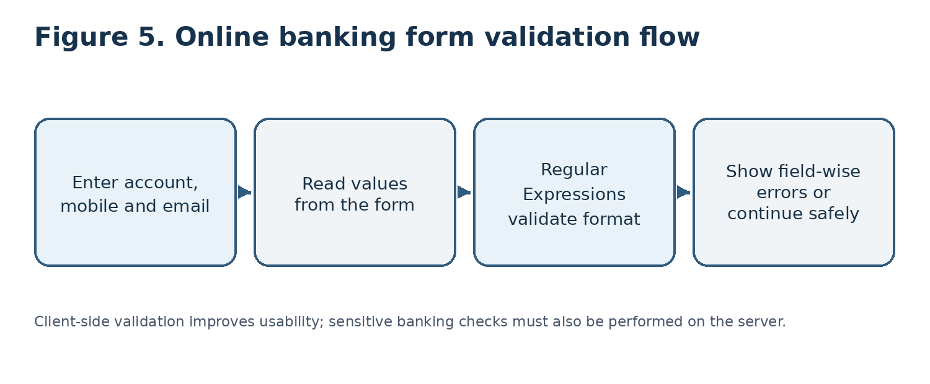
Figure 5: Online banking form validation flow.

REFERENCES
1. MDN Web Docs. Document Object Model (DOM). https://developer.mozilla.org/en-US/docs/Web/API/Document_Object_Model
2. MDN Web Docs. Regular expressions. https://developer.mozilla.org/en-US/docs/Web/JavaScript/Guide/Regular_expressions
3. MDN Web Docs. HTML forms and client-side form validation. https://developer.mozilla.org/en-US/docs/Learn/Forms/Form_validation
4. MDN Web Docs. Fetch API. https://developer.mozilla.org/en-US/docs/Web/API/Fetch_API
5. MDN Web Docs. XMLHttpRequest. https://developer.mozilla.org/en-US/docs/Web/API/XMLHttpRequest
6. MDN Web Docs. Using XMLHttpRequest. https://developer.mozilla.org/en-US/docs/Web/API/XMLHttpRequest_API/Using_XMLHttpRequest
7. TypeScript Documentation. The TypeScript Handbook. https://www.typescriptlang.org/docs/handbook/intro.html
8. TypeScript Documentation. Classes. https://www.typescriptlang.org/docs/handbook/2/classes.html
9. WHATWG. HTML Living Standard. https://html.spec.whatwg.org/
10. OWASP Foundation. Input Validation Cheat Sheet. https://cheatsheetseries.owasp.org/cheatsheets/Input_Validation_Cheat_Sheet.html

